Cloud-Based Smart Traffic Management System

Submitted by,

Name | Roll No. | Registration No.
Debarpan Das | 11771024018 | 241170510018 of 2024-2026
Shubhranil Karmakar | 11771024059 | 241170510059 of 2024-2026
Surjendu Nandi | 11771024069 | 241170510069 of 2024-2026
Sk Dilraj Muhammad | 11771024061 | 241170510061 of 2024-2026

Under the guidance of
Dr. Pramit Ghosh
Dept. of Master of computer Applications (MCA)
RCC Institute of Information Technology

PROJECT REPORT SUBMITTED IN PARTIAL FULFILLMENT OF THE REQUIREMENTS FOR THE DEGREE OF

Master of Computer Applications(MCA)

RCC INSTITUTE OF INFORMATION TECHNOLOGY



Department : Master of Computer Applications

RCC INSTITUTE OF INFORMATION TECHNOLOGY

[Affiliated to West Bengal University of Technology]

CANAL SOUTH ROAD, BELIAGHATA, KOLKATA-700015

Signature of Guide: ____________________
( Dr. Pramit Ghosh )

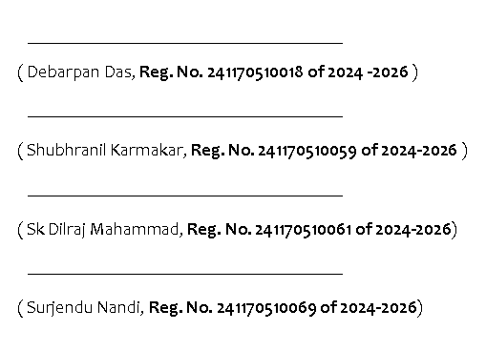
ABSTRACT
Traffic congestion has become one of the major problems in modern urban areas due to the rapid increase in the number of vehicles and inefficient traffic signal systems. Traditional traffic signals generally operate on fixed timing cycles and cannot adapt according to changing traffic conditions. This often leads to unnecessary delays, fuel wastage, increased air pollution, and long waiting times at road intersections. Efficient and intelligent traffic management has therefore become an important requirement for developing smart and sustainable cities.
This project proposes a Cloud-Based Smart Traffic Management System with Emergency Vehicle Prioritization using Artificial Intelligence, Computer Vision, IoT communication, and Embedded Systems. The proposed system is designed to monitor traffic conditions in real time and dynamically control traffic signals according to traffic density and road conditions. The system uses the YOLOv8 deep learning model for vehicle detection and counting. Cameras placed at different sides of a road intersection continuously capture traffic images, and the YOLOv8 model analyzes these images to detect vehicles such as cars, buses, trucks, and motorcycles. Based on the detected vehicle count and waiting time, the system calculates lane priority and dynamically adjusts traffic signal timing for smoother and more efficient traffic flow.
To further improve the system, an audio-based ambulance siren detection mechanism using the
YAMNet (Yet Another Mobile Neural Network) deep learning model has been integrated. Mobile devices placed near road intersections act as microphones and continuously monitor environmental sounds. The YAMNet model processes the incoming audio streams and detects ambulance sirens in real time. Whenever an ambulance siren is detected, the corresponding lane is immediately assigned maximum priority by temporarily overriding the normal traffic cycle. This allows faster and safer movement of emergency vehicles through crowded intersections and improves emergency response efficiency.
The system also uses MQTT cloud communication for transmitting control commands between the Python server and the ESP32 micro controller. The Python server processes traffic and audio information and sends signal control commands through the MQTT broker. The ESP32 receives these commands and controls the traffic signal LEDs accordingly. The proposed system combines computer vision, audio intelligence, cloud communication, and embedded traffic control to create an intelligent and adaptive traffic management solution suitable for smart city infrastructure.

OBJECTIVES OF THE PROJECT
The major objectives of this project are:
- To reduce traffic congestion and vehicle waiting time.
- To detect and count vehicles using YOLOv8.
- To dynamically control traffic signals according to traffic density.
- To detect ambulance sirens using YAMNet.
- To prioritize emergency vehicles automatically.
- To establish MQTT-based cloud communication.
- To control traffic signals using ESP32.
- To improve traffic flow efficiency and emergency response time.
- To support intelligent smart city infrastructure.
METHODOLOGY
Traffic images from four sides of a road intersection are processed using the YOLOv8 deep learning model to detect and count vehicles in real time. Based on vehicle count and waiting time, the system estimates traffic density for each lane.
Environmental audio from nearby mobile devices is analyzed using the YAMNet model to detect ambulance sirens. If a siren is detected, the system immediately prioritizes the corresponding lane by overriding the normal traffic cycle.
The traffic controller calculates lane priority and sends control commands through MQTT cloud communication. The ESP32 micro controller receives these commands and controls the traffic signal LEDs accordingly. This enables intelligent and adaptive traffic management.

ADVANTAGES OF THE SYSTEM
- Reduces traffic congestion at intersections
- Minimizes unnecessary vehicle waiting time
- Dynamically controls traffic signals in real time
- Provides automatic priority for emergency vehicles
- Improves ambulance movement and emergency response efficiency
- Reduces fuel consumption and air pollution
- Uses AI-based accurate vehicle detection
- Supports smart city infrastructure
- Low-cost and scalable implementation
- Provides intelligent and adaptive traffic management

CONCLUSION
The proposed Cloud-Based Smart Traffic Management System with Emergency Vehicle Prioritization provides an intelligent and efficient solution for modern urban traffic problems. By integrating YOLOv8-based vehicle detection, YAMNet-based ambulance siren detection, MQTT cloud communication, and ESP32 traffic control, the system can dynamically manage traffic signals according to real-time road conditions.
The project improves traffic flow efficiency by reducing congestion and minimizing vehicle waiting time. The integration of ambulance siren detection further enhances the system by enabling automatic emergency vehicle prioritization, allowing ambulances to pass through traffic intersections quickly and safely.
The use of Artificial Intelligence, IoT communication, and Embedded Systems makes the proposed system adaptive, scalable, reliable, and suitable for smart city infrastructure. The project demonstrates how modern technologies can be combined to build intelligent and low-cost traffic management systems capable of handling real-world traffic challenges effectively.
______________________________________________________________________________________

